[MAIX](https://www.seeedstudio.com/sipeed-maix.html) is Sipeed' s purpose-built product series designed to run AI at the edge. Move AI models from cloud down to devices on the edge of the network where they can run faster, at lower cost, and with greater privacy.

Since the 64-bit RISC-V AI module [MAIX-I](https://www.seeedstudio.com/Sipeed-MAIX-I-module-WiFi-version-1st-RISC-V-64-AI-Module-K210-inside-p-3206.html) first released at the end of last year, more development boards, peripherals, documents and multi-platform compatibility supports have launched.

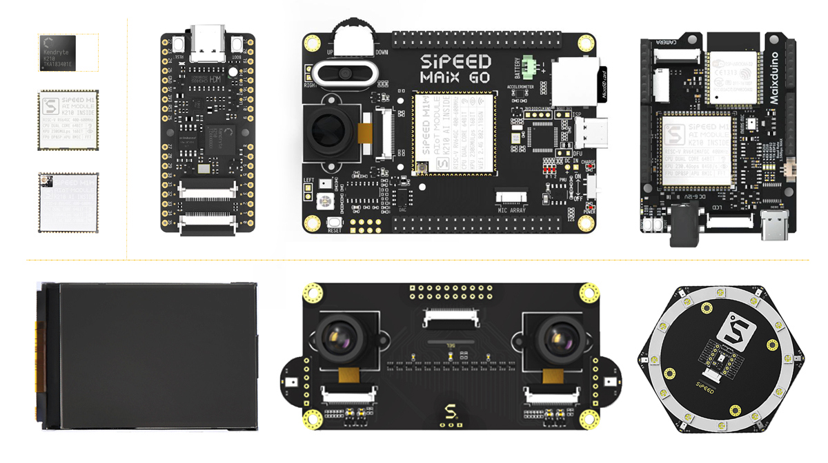



Based on the MAIX module, the newly released [Maixduino](https://www.seeedstudio.com/Sipeed-Maixduino-Kit-for-RISC-V-AI-IoT-p-4047.html) is a RISC-V 64 development board for AI + IoT applications. Different from [previous Sipeed MAIX dev. boards,](https://www.seeedstudio.com/sipeed-maix.html) Maixduino was designed in an Arduino Uno form factor, with an ESP32 module on board together with the MAIX AI module. The support of Arduino compatible interface as well as Arduino IDE enable you update your Arduino projects from IoT to AIoT easily without any additional cost!

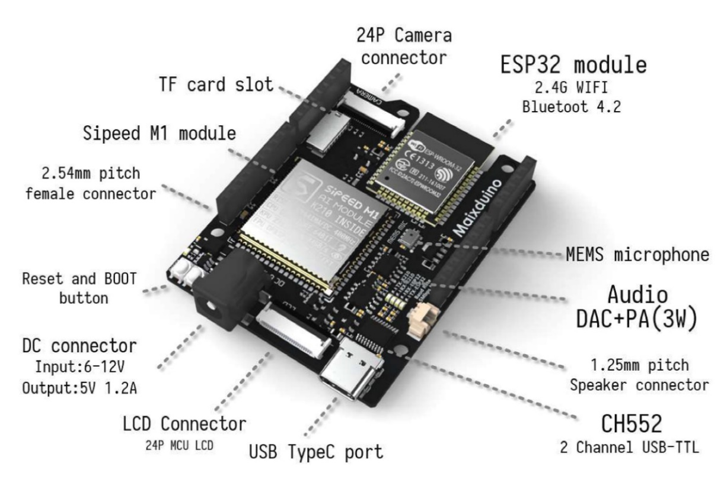

Sipeed MAIX module is based on the Kendryte K210 processor, which has two 64-bit RISC-V CPU cores, each with a built-in independent FPU. Support TensorFlow/Keras/Darknet DNN Framework and TinyYOLOv2 Model (after prune), QVGA @ 60fps or VGA @ 30fps image identification.

We added the full [ArduinoCore-API](https://github.com/Seeed-Studio/ArduinoCore-k210) interface to support Arduino IDE, Linux, Windows, Mac OS X, and other development environments in Apr. With the support of the [ArduinoCore-k210](https://github.com/Seeed-Studio/ArduinoCore-k210) all k210-based development boards can run [Grove](https://www.seeedstudio.com/category/Grove-c-1003.html) Arduino Library and many excellent [Arduino libraries](https://www.arduinolibraries.info/) in the community of Arduino.

**Thus, we will launch a Grove Kit for Maixduino which including Maixduino board, OV2640 camera module, 2.4-inch TFT display, Grove base shield and 9 most expected Grove Modules. The 9 grove modules will be selected by Seeekers through votes, and of course the Kit will be much cheaper than you buy Maixduino and the other Grove modules separately.**

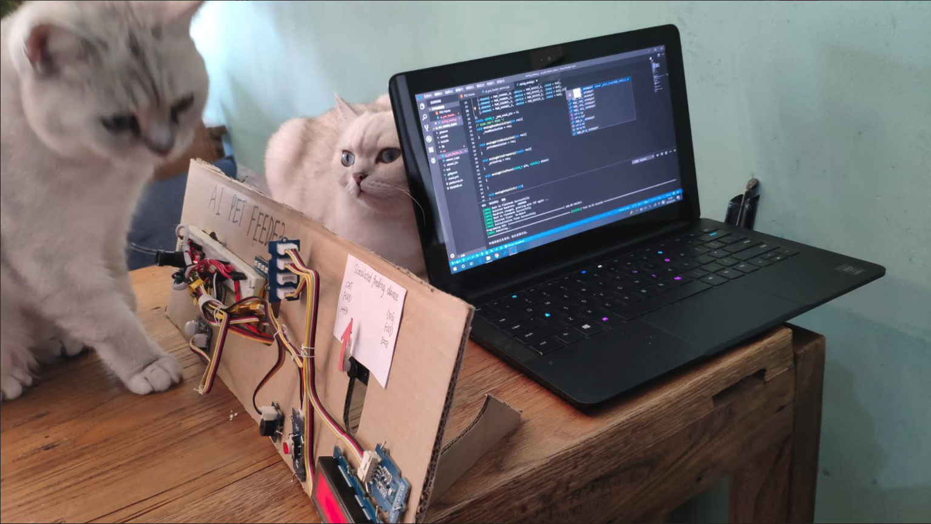

This demo video is about a prototype of smart auto pet feeder which was built with Sipeed Maix Bit dev board and Grove Modules. The feeder distinguishes cats and dogs before feeding. And you can imagine that, it will be simpler if you replace Maix Bit with Maixduino dev board + Grove Base Shield.

Here’s a brief introduction about Grove:



[Grove](https://www.seeedstudio.com/category/Grove-c-1003.html) is an open source, modulated, and ready-to-use toolset. It takes a building block approach to assemble electronics. Compared with the traditional, complicated learning method of using a breadboard and various electronic components to assemble a project, Grove simplifies the learning process significantly.

The Grove System consists of a base shield and various modules with standardized connectors. The base shield allows for easy connection of any microprocessor input or output from the Grove modules, and every Grove module addresses a single function, such as a simple button or a more complex sensor.

There are already more than 200 Grove modules and each one comes with clear documentation and demo code to help you get started quickly.